Height Gauge
# Source: AI Source: Provided by: [Data Path: Persons Table -> ID Column: 1, Name_En Column: Motasem Essam] -> From: [ChatGPT] on [7/17/2026]
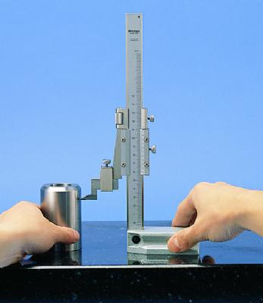
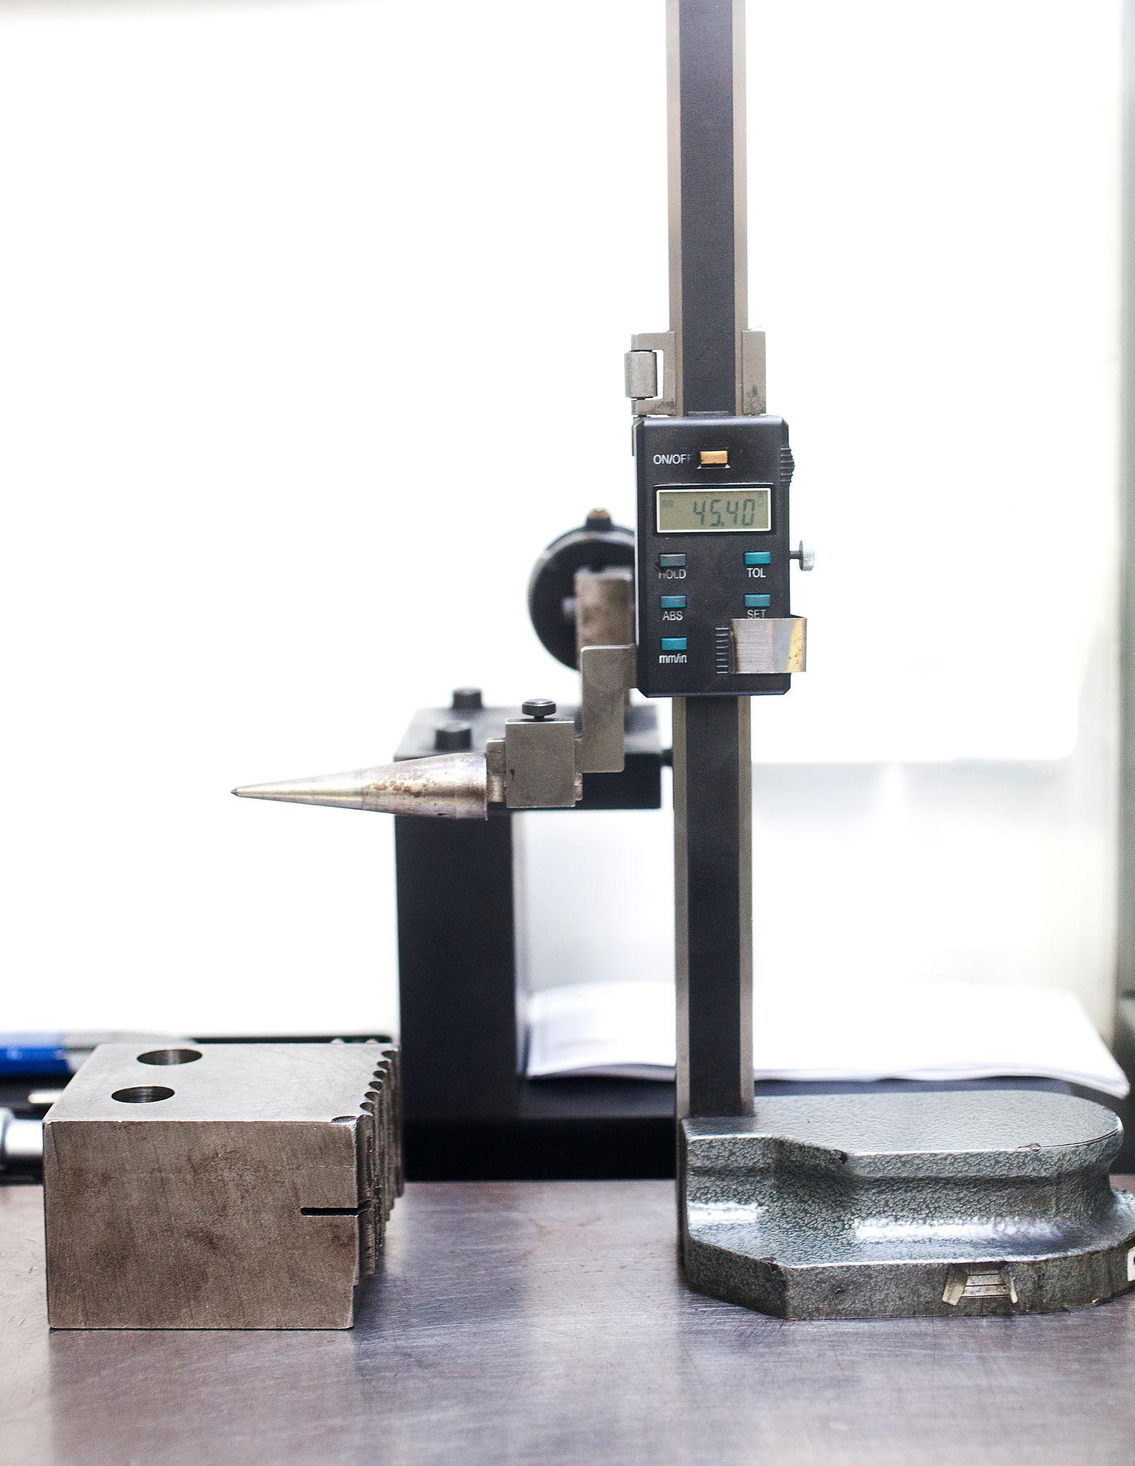
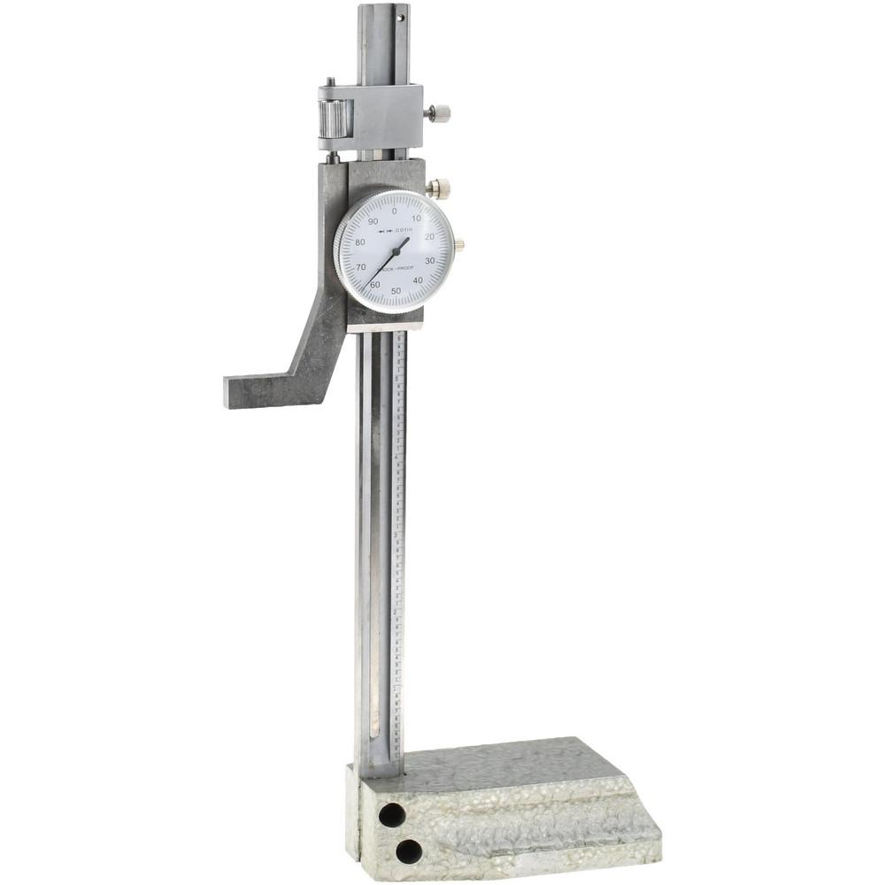
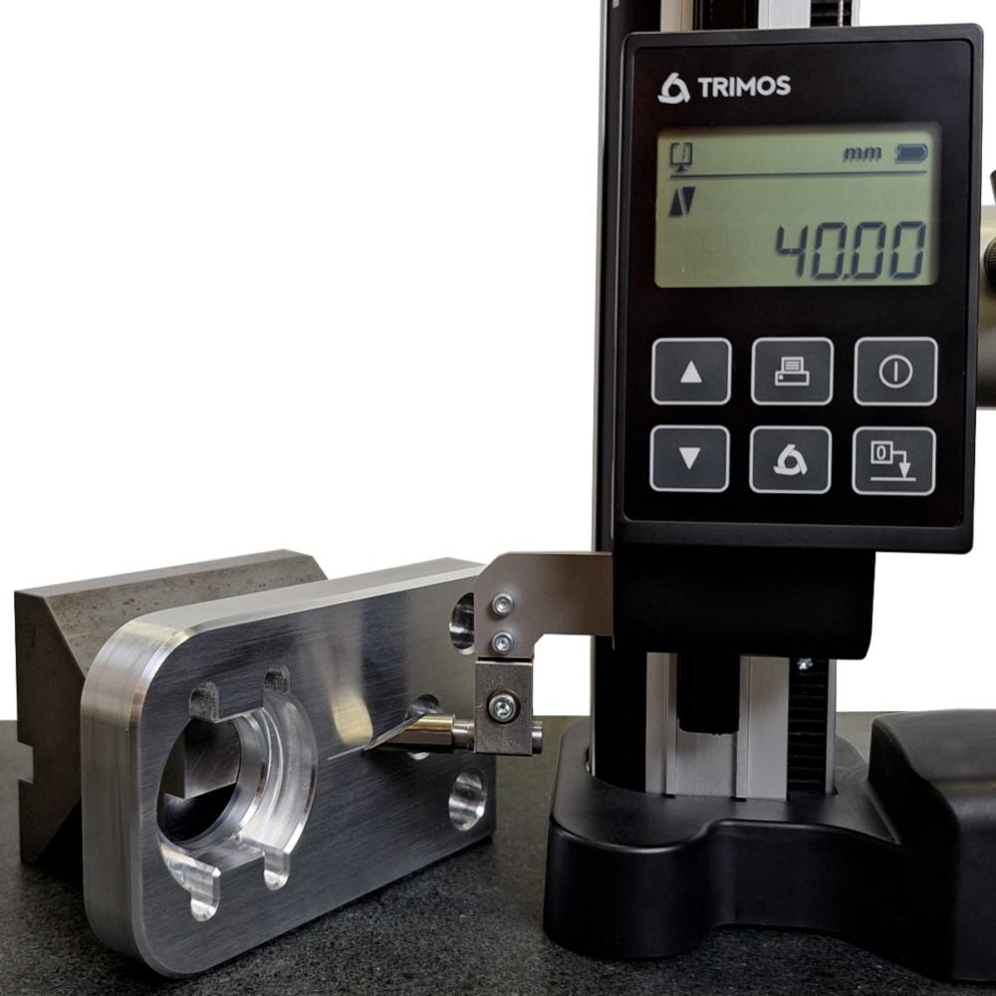
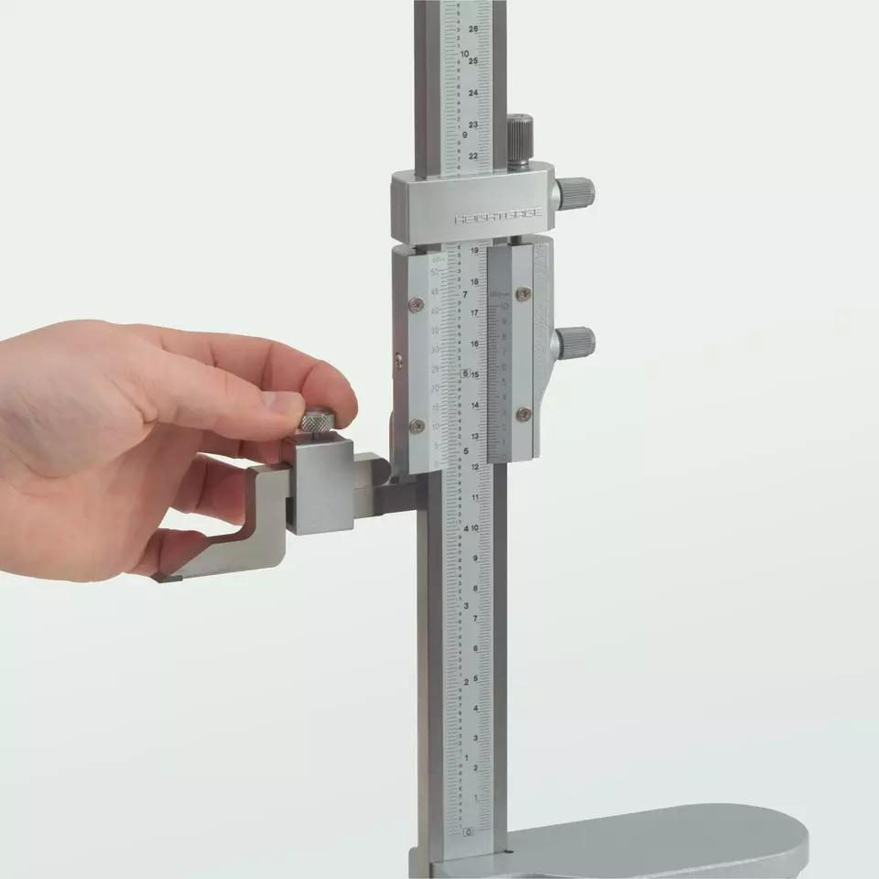
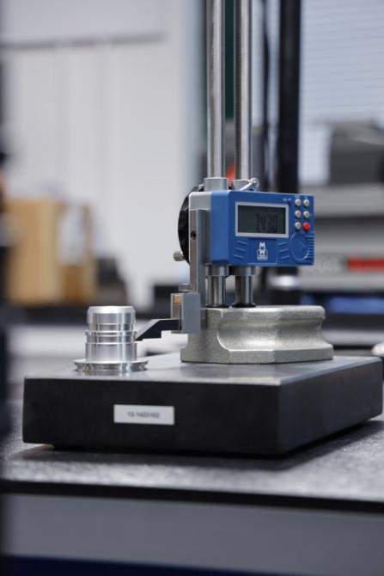
A Height Gauge is a precision measuring instrument used to measure the vertical height of objects from a reference surface. It is also used for marking, layout work, and inspection in manufacturing and quality control.
Height gauges are typically used on a surface plate, which provides a highly accurate reference plane.

Definition
# Source: AI Source: Provided by: [Data Path: Persons Table -> ID Column: 1, Name_En Column: Motasem Essam] -> From: [ChatGPT] on [7/17/2026]
A Height Gauge is a precision measuring instrument designed to measure vertical dimensions and mark reference heights from a flat datum surface.

Purpose
# Source: AI Source: Provided by: [Data Path: Persons Table -> ID Column: 1, Name_En Column: Motasem Essam] -> From: [ChatGPT] on [7/17/2026]
A Height Gauge is used to:
- Measure vertical heights.
- Measure step heights.
- Measure hole center heights.
- Measure feature locations.
- Mark layout lines.
- Inspect machined components.
- Perform precision quality control.

Principle of Operation
# Source: AI Source: Provided by: [Data Path: Persons Table -> ID Column: 1, Name_En Column: Motasem Essam] -> From: [ChatGPT] on [7/17/2026]
A Height Gauge operates by:
- Placing the base on a precision surface plate.
- Moving the measuring slider vertically along the beam.
- Reading the measurement using a Vernier scale, dial indicator, or digital display.
- Using the scriber or probe to contact or mark the workpiece.

Main Components
# Source: AI Source: Provided by: [Data Path: Persons Table -> ID Column: 1, Name_En Column: Motasem Essam] -> From: [ChatGPT] on [7/17/2026]
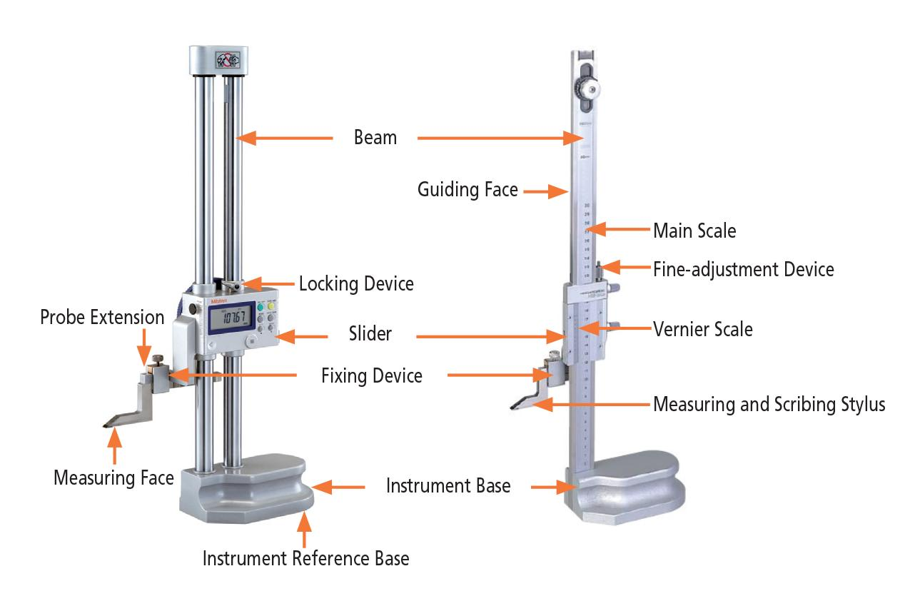
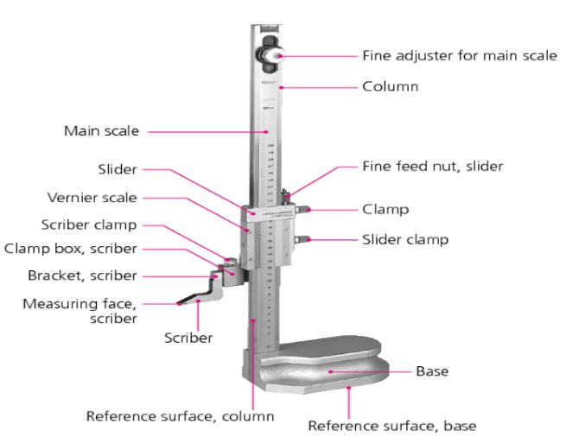
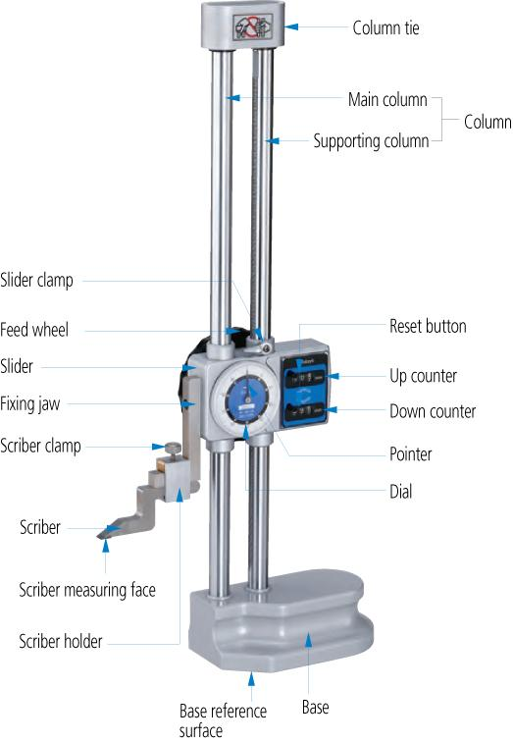
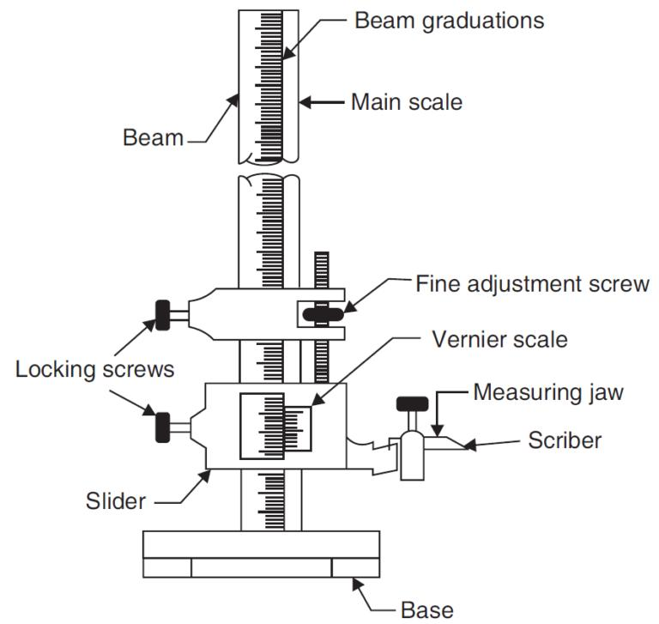
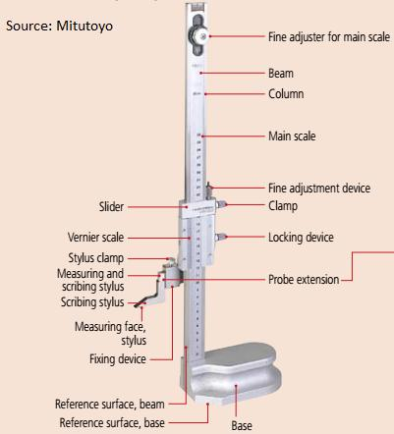
A typical Height Gauge consists of:
- Heavy base
- Vertical beam (main scale)
- Measuring slider
- Vernier scale, dial, or digital display
- Scriber or measuring probe
- Fine adjustment mechanism
- Locking screw

Types of Height Gauges

1. Vernier Height Gauge
# Source: AI Source: Provided by: [Data Path: Persons Table -> ID Column: 1, Name_En Column: Motasem Essam] -> From: [ChatGPT] on [7/17/2026]
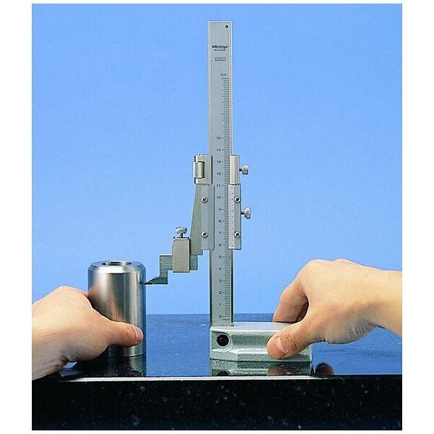
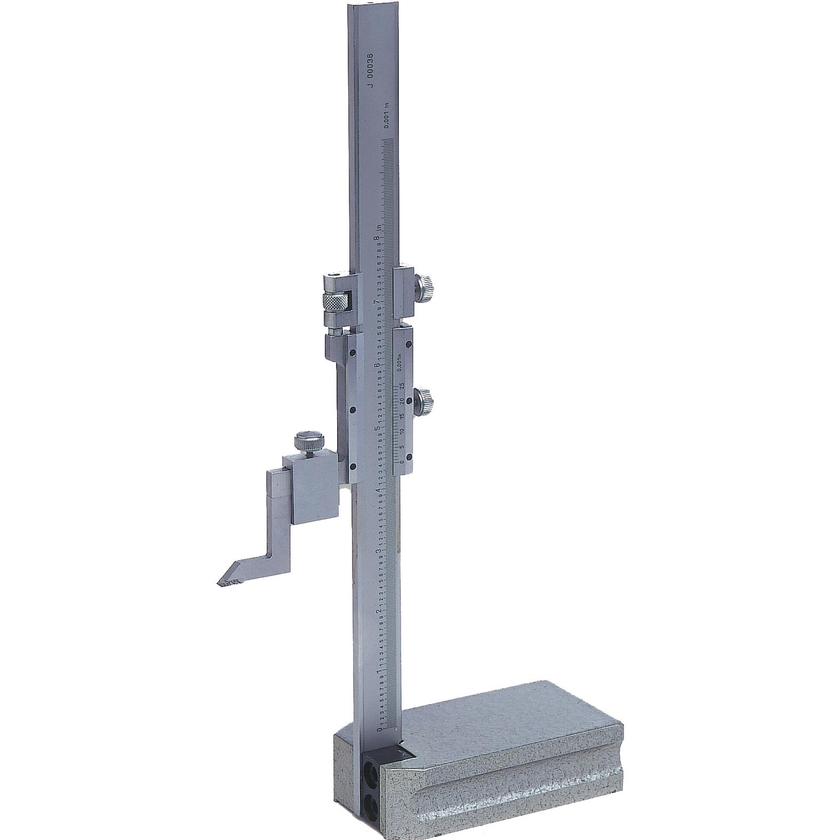
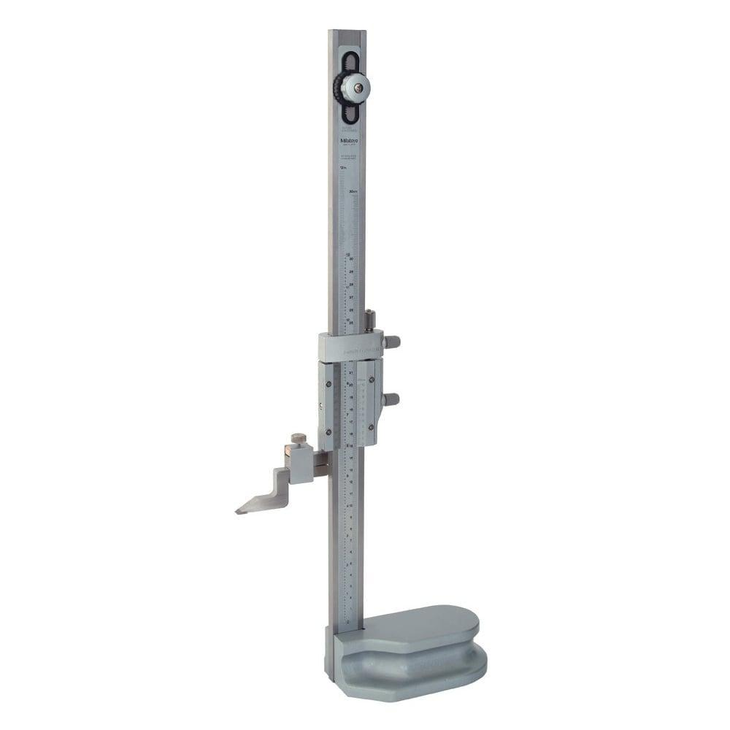
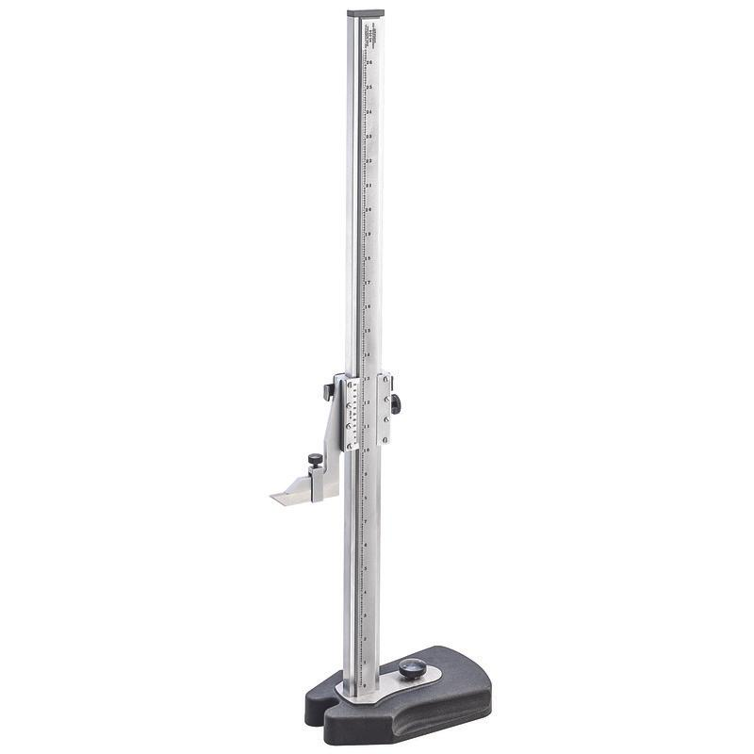
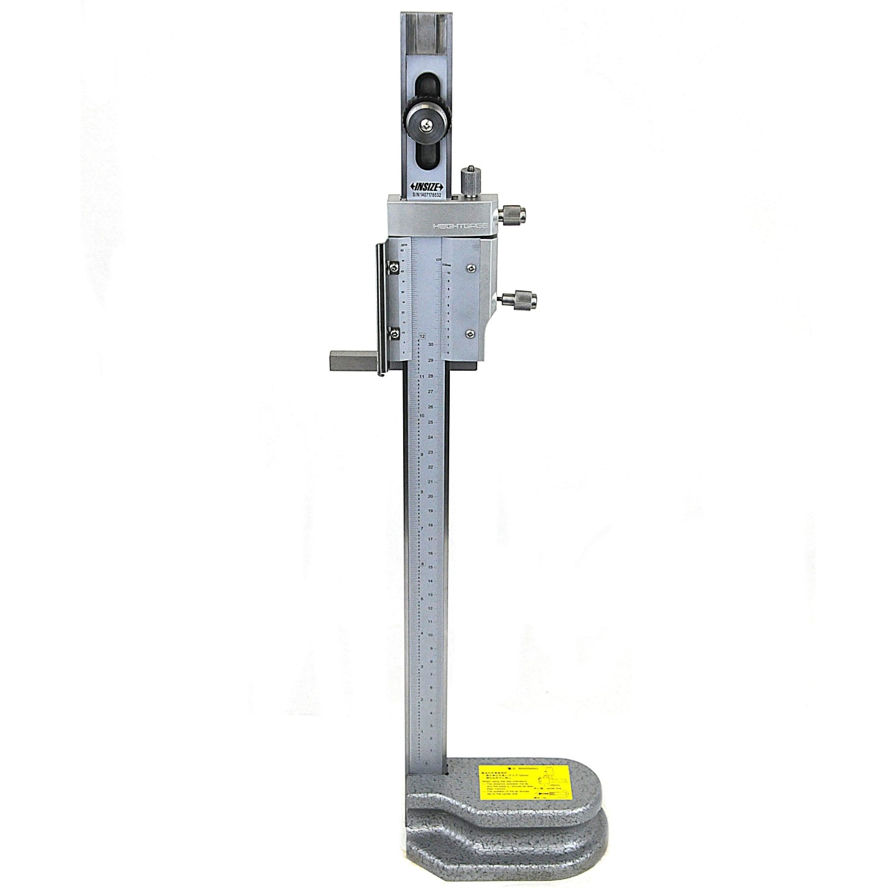
Description
Uses a main scale and a vernier scale for precise manual measurement.
Typical Least Count
- 0.02 mm
Applications
- Workshop measurements
- Inspection
- Layout marking

2. Dial Height Gauge
# Source: AI Source: Provided by: [Data Path: Persons Table -> ID Column: 1, Name_En Column: Motasem Essam] -> From: [ChatGPT] on [7/17/2026]
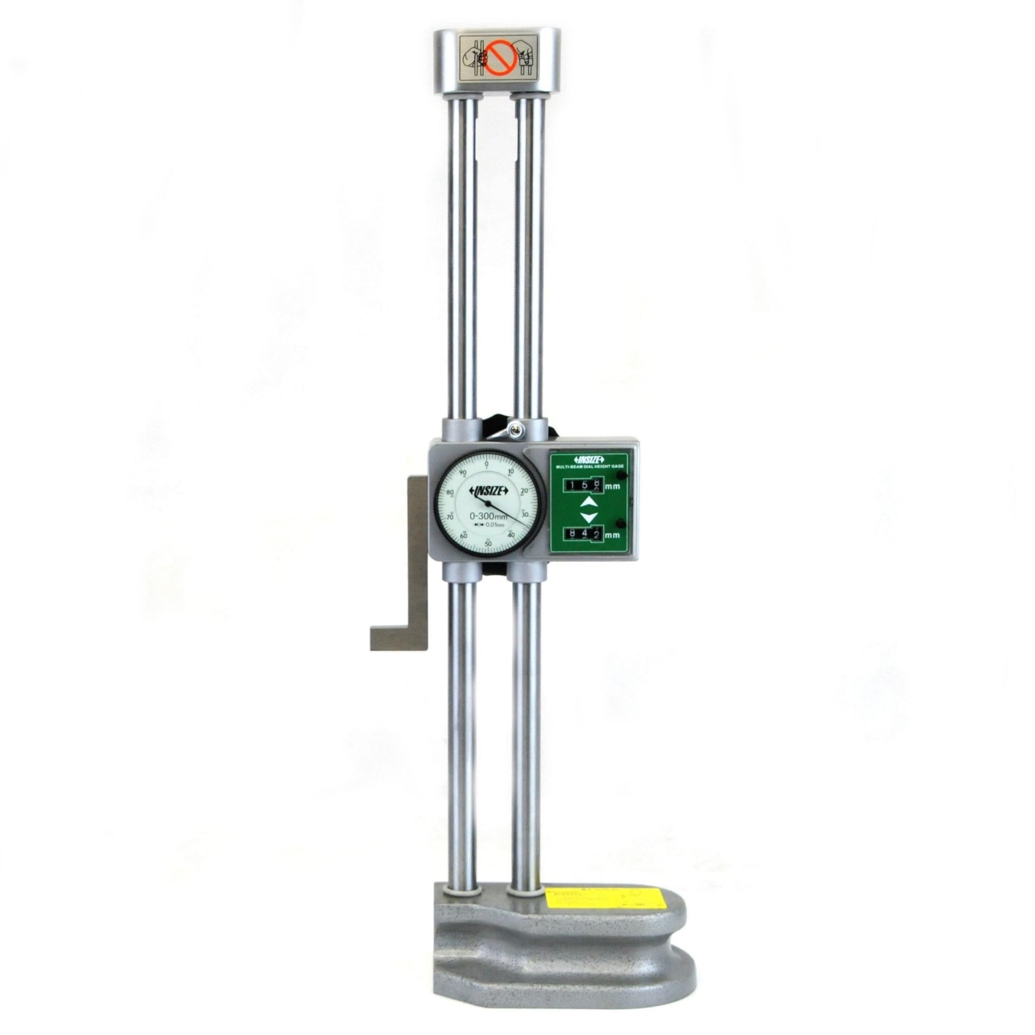
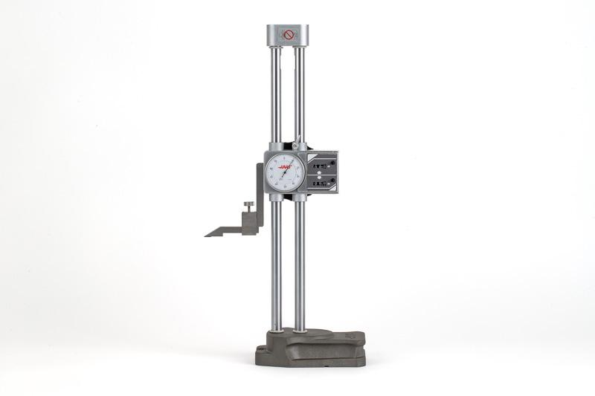
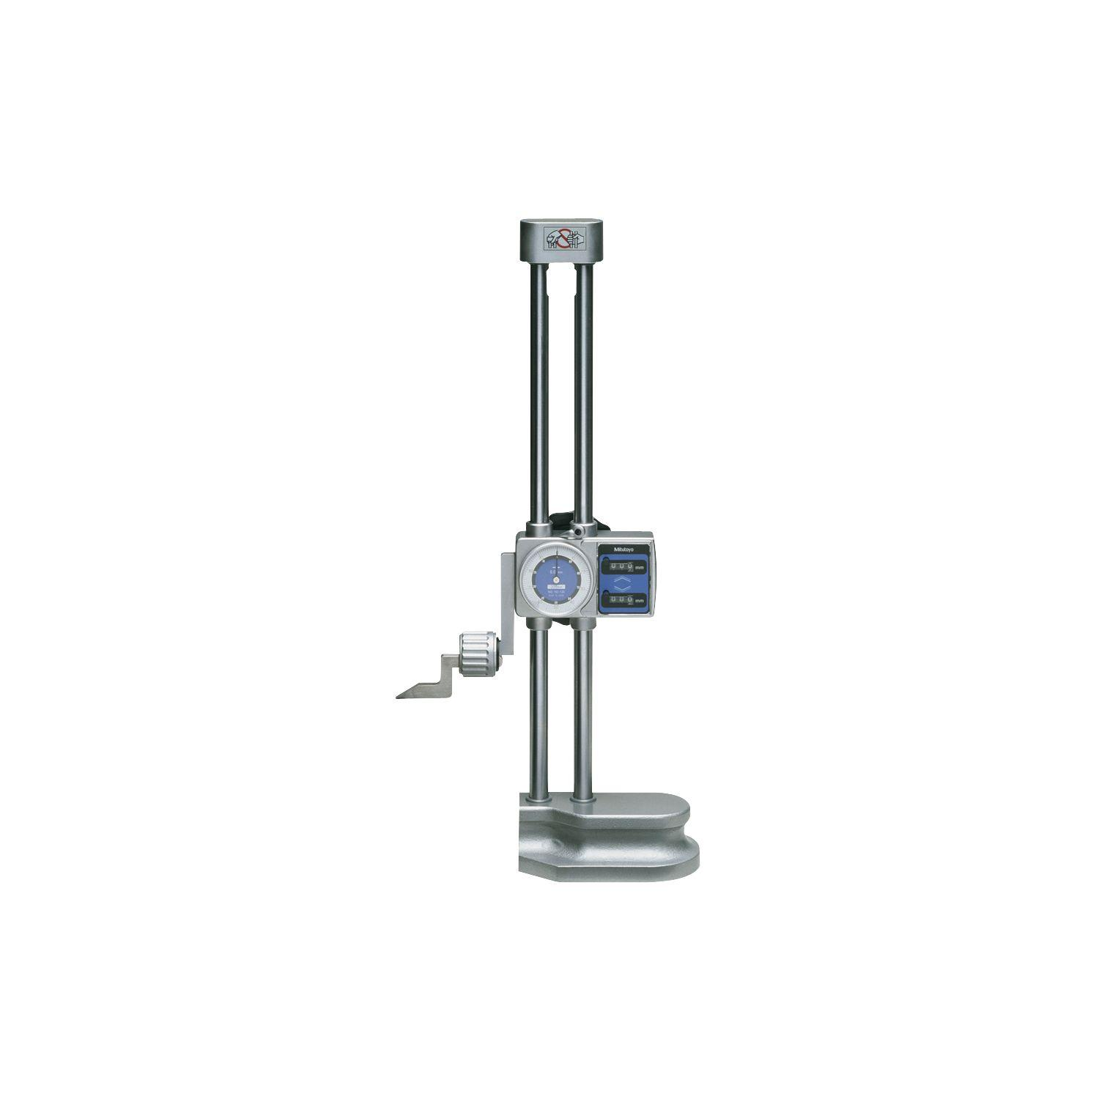
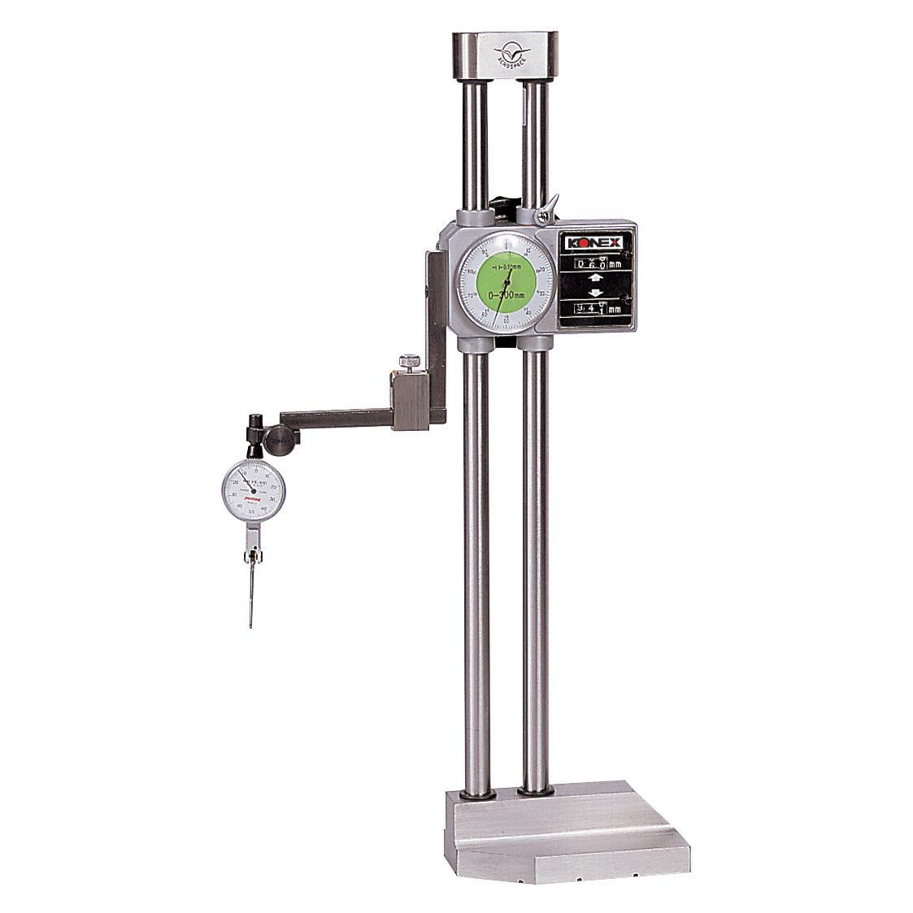
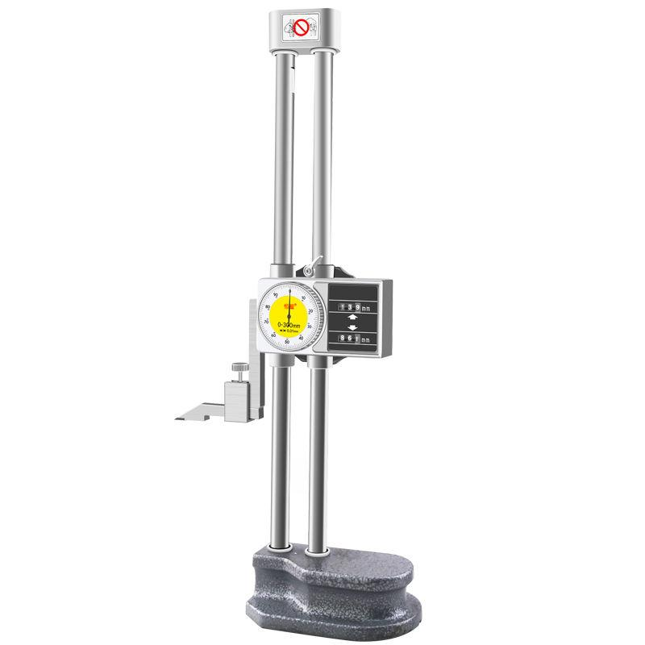
Description
Uses a dial indicator for easier reading than a vernier scale.
Typical Least Count
- 0.01 mm
- 0.02 mm
Applications
- Precision inspection
- Manufacturing
- Quality control

3. Digital Height Gauge
# Source: AI Source: Provided by: [Data Path: Persons Table -> ID Column: 1, Name_En Column: Motasem Essam] -> From: [ChatGPT] on [7/17/2026]
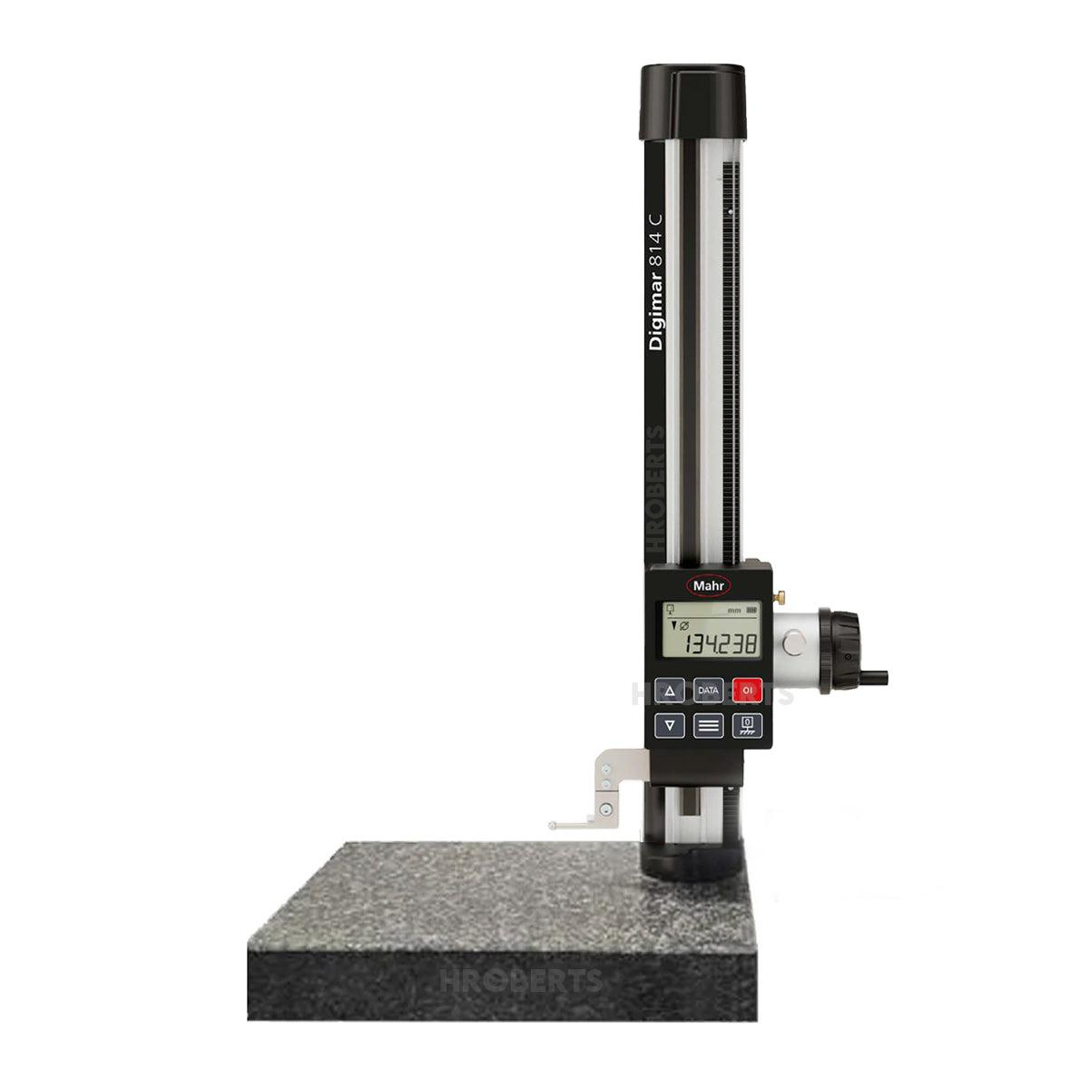
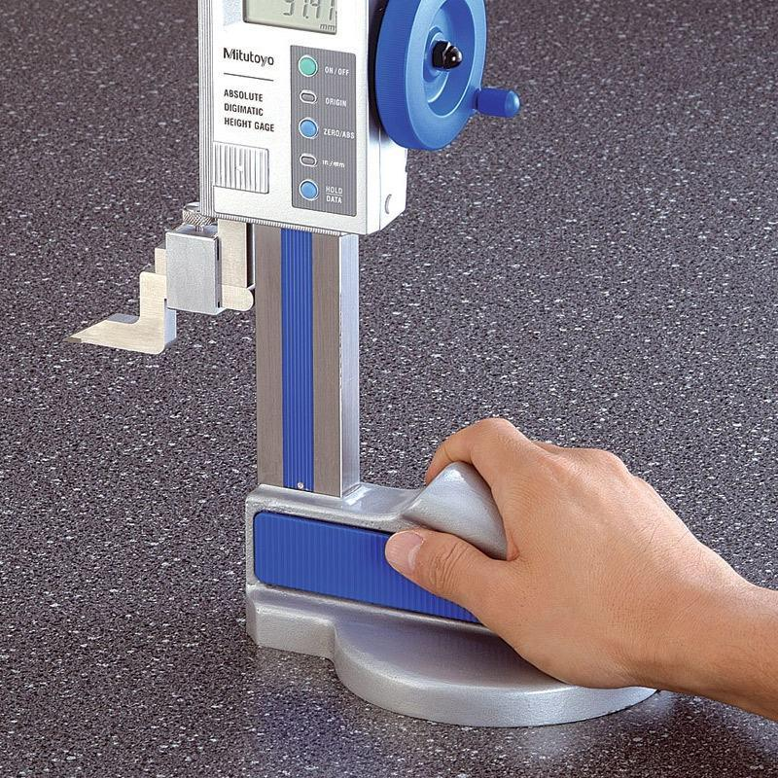
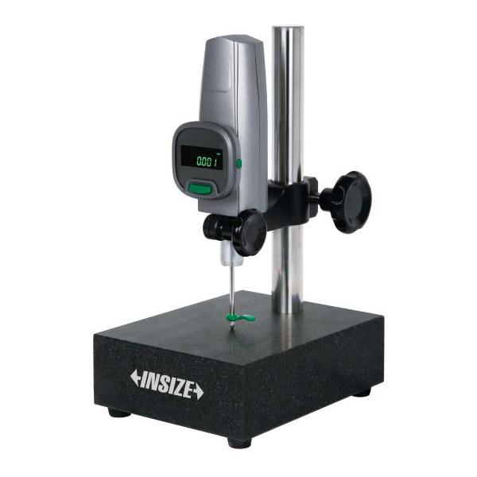
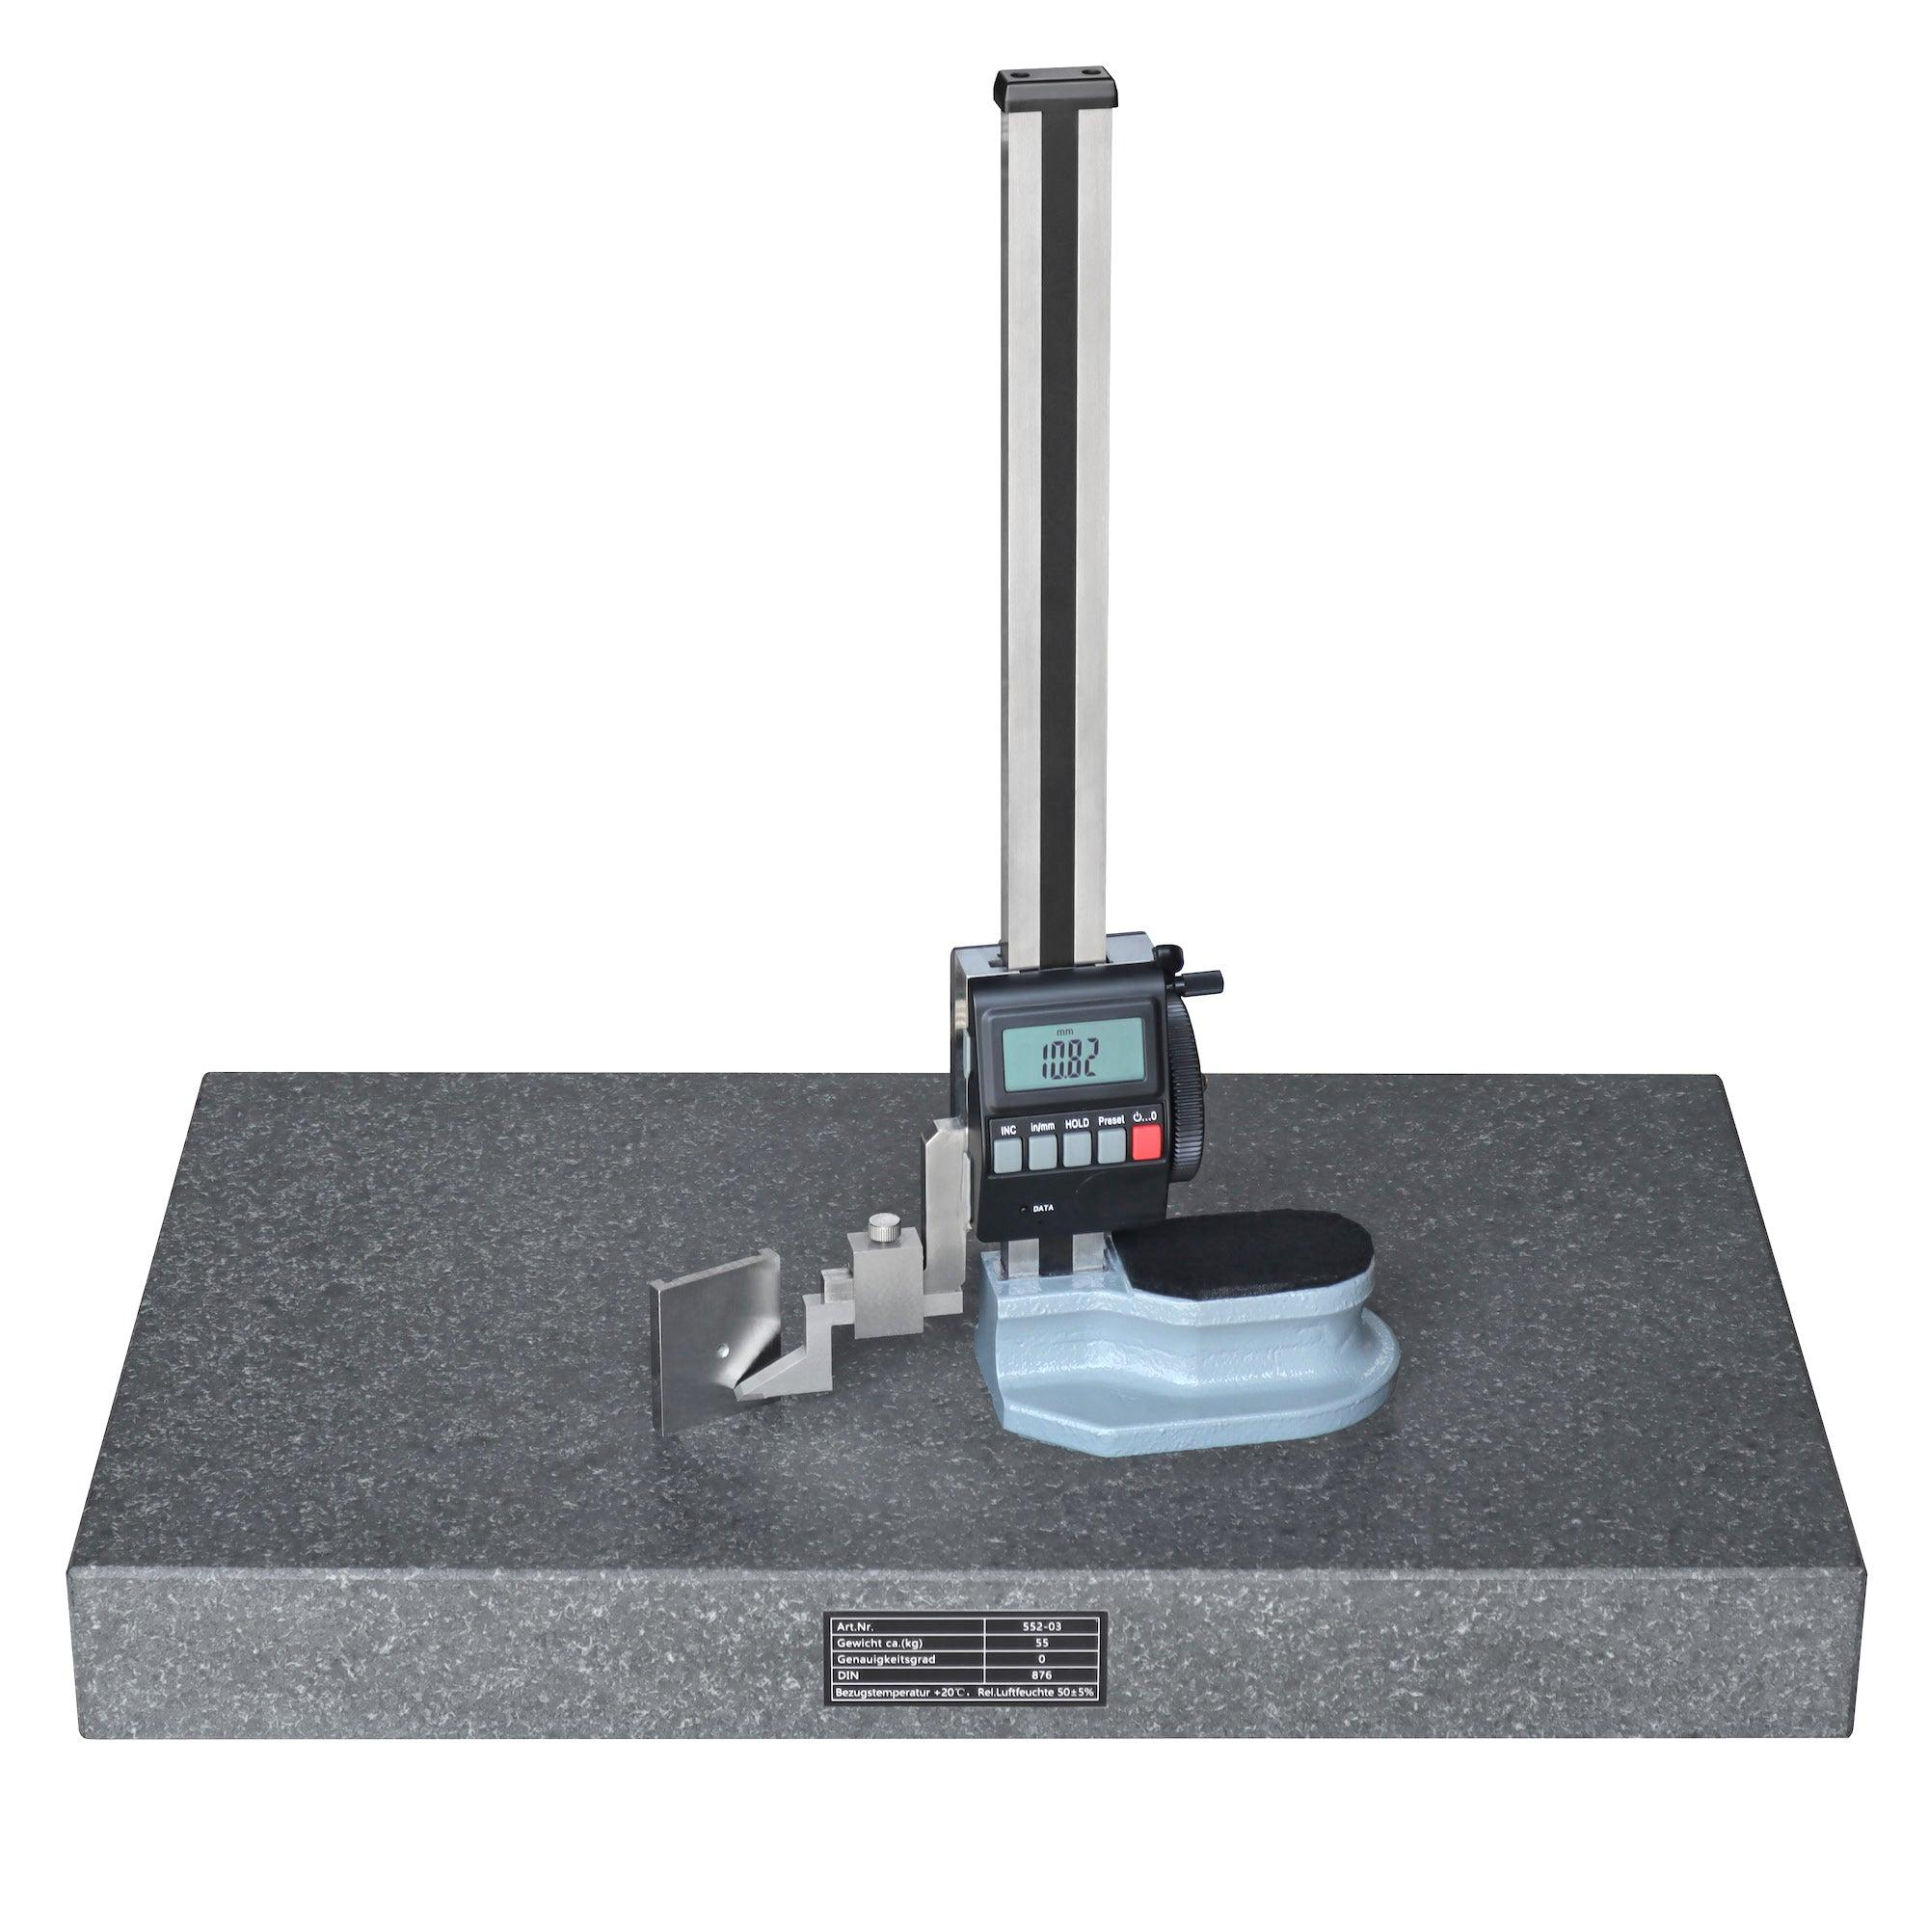
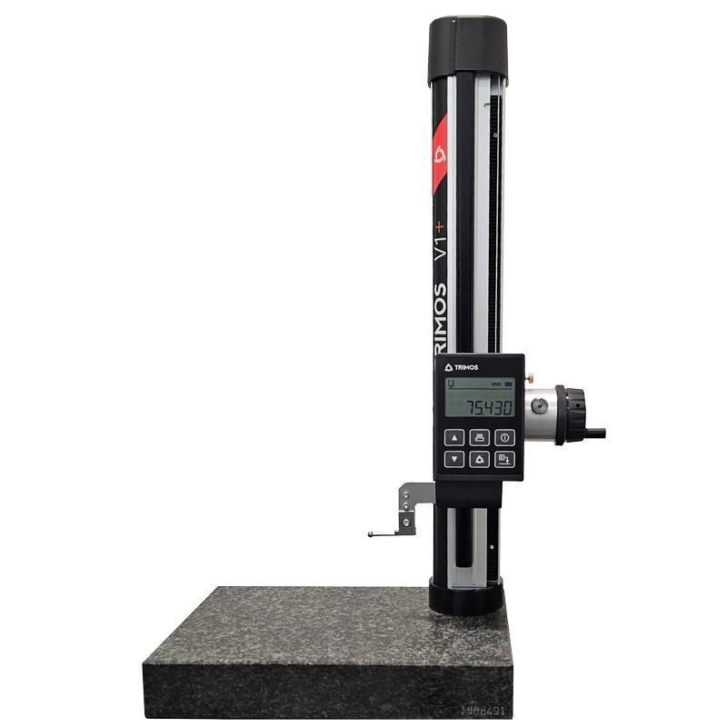
Description
Uses an electronic sensor and LCD display to provide direct digital readings.
Features
- Digital display
- Metric/Imperial conversion
- Zero setting
- High accuracy
Typical Least Count
- 0.01 mm
- 0.001 mm (high-end models)
Applications
- CNC inspection
- Metrology laboratories
- Precision manufacturing

Measuring Range
# Source: AI Source: Provided by: [Data Path: Persons Table -> ID Column: 1, Name_En Column: Motasem Essam] -> From: [ChatGPT] on [7/17/2026]
Common measuring ranges:
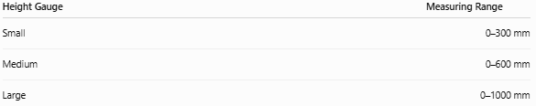
Height Gauge | Measuring Range
Small | 0–300 mm
Medium | 0–600 mm
Large | 0–1000 mm

Least Count (Resolution)
# Source: AI Source: Provided by: [Data Path: Persons Table -> ID Column: 1, Name_En Column: Motasem Essam] -> From: [ChatGPT] on [7/17/2026]
Typical values:
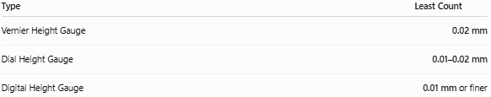
Type | Least Count
Vernier Height Gauge | 0.02 mm
Dial Height Gauge | 0.01–0.02 mm
Digital Height Gauge | 0.01 mm or finer

How to Measure with a Height Gauge
# Source: AI Source: Provided by: [Data Path: Persons Table -> ID Column: 1, Name_En Column: Motasem Essam] -> From: [ChatGPT] on [7/17/2026]
- Place the height gauge on a clean surface plate.
- Position the workpiece on the same surface plate.
- Move the slider until the probe or scriber contacts the measurement point.
- Use the fine adjustment for accurate positioning.
- Lock the slider.
- Read the measurement.
- Record the value with the correct unit.

Example
# Source: AI Source: Provided by: [Data Path: Persons Table -> ID Column: 1, Name_En Column: Motasem Essam] -> From: [ChatGPT] on [7/17/2026]
Suppose the display shows:
125.48 mm
The measured height is:
- 125.48 mm
- 12.548 cm
- 0.12548 m

Accuracy
# Source: AI Source: Provided by: [Data Path: Persons Table -> ID Column: 1, Name_En Column: Motasem Essam] -> From: [ChatGPT] on [7/17/2026]
Typical accuracy:
- ±0.02 mm
- ±0.01 mm
- Better on high-end digital models
Accuracy depends on:
- Calibration
- Surface plate quality
- Instrument cleanliness
- Operator technique
- Temperature

Sources of Error
# Source: AI Source: Provided by: [Data Path: Persons Table -> ID Column: 1, Name_En Column: Motasem Essam] -> From: [ChatGPT] on [7/17/2026]
Instrument Errors
- Calibration errors
- Worn scriber
- Loose slider
- Damaged scale

Observation Errors
- Incorrect reading
- Parallax (analog types)
- Display interpretation

Positioning Errors
- Dirty surface plate
- Tilted workpiece
- Incorrect probe contact
- Excessive measuring force

Environmental Errors
- Thermal expansion
- Dust
- Oil film
- Vibration

Applications
# Source: AI Source: Provided by: [Data Path: Persons Table -> ID Column: 1, Name_En Column: Motasem Essam] -> From: [ChatGPT] on [7/17/2026]
Height Gauges are used in:
- Manufacturing
- Machine shops
- Precision engineering
- Quality control
- Tool rooms
- Metrology laboratories
- Inspection departments
- CNC machining
- Aerospace
- Automotive industries

Advantages
# Source: AI Source: Provided by: [Data Path: Persons Table -> ID Column: 1, Name_En Column: Motasem Essam] -> From: [ChatGPT] on [7/17/2026]
A Height Gauge:
- Provides highly accurate vertical measurements.
- Performs both measurement and marking.
- Is ideal for inspection work.
- Works with surface plates for excellent accuracy.
- Is available in manual and digital versions.

Limitations
# Source: AI Source: Provided by: [Data Path: Persons Table -> ID Column: 1, Name_En Column: Motasem Essam] -> From: [ChatGPT] on [7/17/2026]
A Height Gauge:
- Requires a precision surface plate.
- Is less portable than handheld instruments.
- Measures mainly vertical dimensions.
- Must be carefully calibrated and maintained.

Comparison with Other Length Measuring Instruments
# Source: AI Source: Provided by: [Data Path: Persons Table -> ID Column: 1, Name_En Column: Motasem Essam] -> From: [ChatGPT] on [7/17/2026]
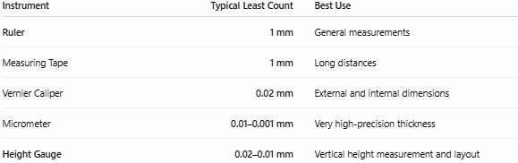
Instrument | Typical Least Count | Best Use
Ruler | 1 mm | General measurements
Measuring Tape | 1 mm | Long distances
Vernier Caliper | 0.02 mm | External and internal dimensions
Micrometer | 0.01–0.001 mm | Very high-precision thickness
Height Gauge | 0.02–0.01 mm | Vertical height measurement and layout

Care and Maintenance
# Source: AI Source: Provided by: [Data Path: Persons Table -> ID Column: 1, Name_En Column: Motasem Essam] -> From: [ChatGPT] on [7/17/2026]
To maintain accuracy:
- Keep the base and surface plate clean.
- Protect the scriber tip.
- Store in a protective case.
- Avoid impacts.
- Calibrate regularly.
- Apply light protective oil to metal surfaces when recommended.

Common Mistakes
# Source: AI Source: Provided by: [Data Path: Persons Table -> ID Column: 1, Name_En Column: Motasem Essam] -> From: [ChatGPT] on [7/17/2026]
- Measuring on a dirty surface plate.
- Using excessive contact force.
- Forgetting to lock the slider before reading.
- Reading the wrong scale (analog models).
- Ignoring calibration or zero checks.

Key Points
# Source: AI Source: Provided by: [Data Path: Persons Table -> ID Column: 1, Name_En Column: Motasem Essam] -> From: [ChatGPT] on [7/17/2026]
- A Height Gauge measures vertical dimensions from a reference surface.
- It is used with a surface plate.
- Common types:
  - Vernier Height Gauge
  - Dial Height Gauge
  - Digital Height Gauge
- Typical least count:
  - 0.02 mm
  - 0.01 mm
- It is widely used for precision measurement, layout, and inspection.

Conclusion
# Source: AI Source: Provided by: [Data Path: Persons Table -> ID Column: 1, Name_En Column: Motasem Essam] -> From: [ChatGPT] on [7/17/2026]
A Height Gauge is a precision instrument specifically designed for measuring and marking vertical dimensions with high accuracy. Used in conjunction with a surface plate, it enables precise measurement of heights, step dimensions, and feature locations while also serving as an effective layout tool. Available in vernier, dial, and digital versions, the height gauge is an essential instrument in manufacturing, metrology, machining, aerospace, automotive engineering, and quality control, where accurate vertical measurements are critical.

